Axios Interceptor.

Jb be hm http request krty hn backend server pa so befor making request if you want to do any action for every request then we will using the interceptor concepts

Request interceptor.

Response interceptor

Ise trah response interceptor ha agr koi response server sa mila ha or usky sth hmy ku6 addition chezain add krvane hn to response interceptor ke help sa krva ly gn

**Axios.default**

Default ke help sy hm jitney be axios request ha un sbka ak url dy skty hn

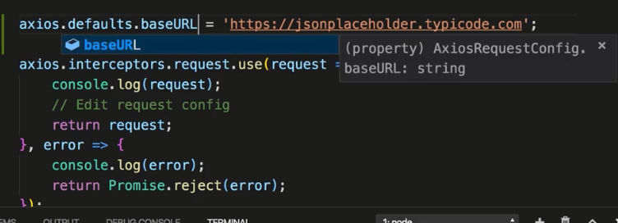

**Axios Instance of.**

Axios.create ke help sy axios ka instance create hota ha or phr ya wala instance use jis b request na use krna ho us component ma import kr ln gn axios ko

